Irena Tomažin Zagoričnik: Mes(t)o glasu
Tech - rider

Stage:
- stage min. 10 x 10 m
- stage without curtains (white walls, bare stage)
- white dance floor
(Images attached bellow.)

Scenography:
- 1 music note stand
- 7 chairs (possibly the same as the audience chairs)
- 5 small black tables (can be provided by the producer)
- 2 glass jugs + 8 glasses (for water)
- 1 x metronome, 1 x microphone + cable, 2 small yamaha speakers (scenic elements – provided by the producer)

Sound:
- sound mixing table with at least 4 sub-groups
- at least 2x aux
- 1 x condenser microphone (broadband) on stand
- 1 x central sound system with subwoofers, positioned at the back of the stage
- 2 x active speakers, positioned extremely left and right behind the audience
- all necessary cables
Sound is controlled from computer/sound card (provided by the producer's technician).

Lights:
- 30 x PC (1kW) – with shutters
- 4 x PC (2kW) – with shutters
- 4 x zoom profile
- 10 x PAR 64 (CP62), 1kW
- 3 x halogen flood light/cyclorama lights
- 2 x low floor stand
- 8 x parallel floor stand (possibly also low floor stand)
- min. 36 ch. dimmer
- audience light must be controlled from light console or lighting booth

Changing room(s):
- changing room should provide enough space for 4 performers (with toilet and shower)
- drinking water should be available at all times
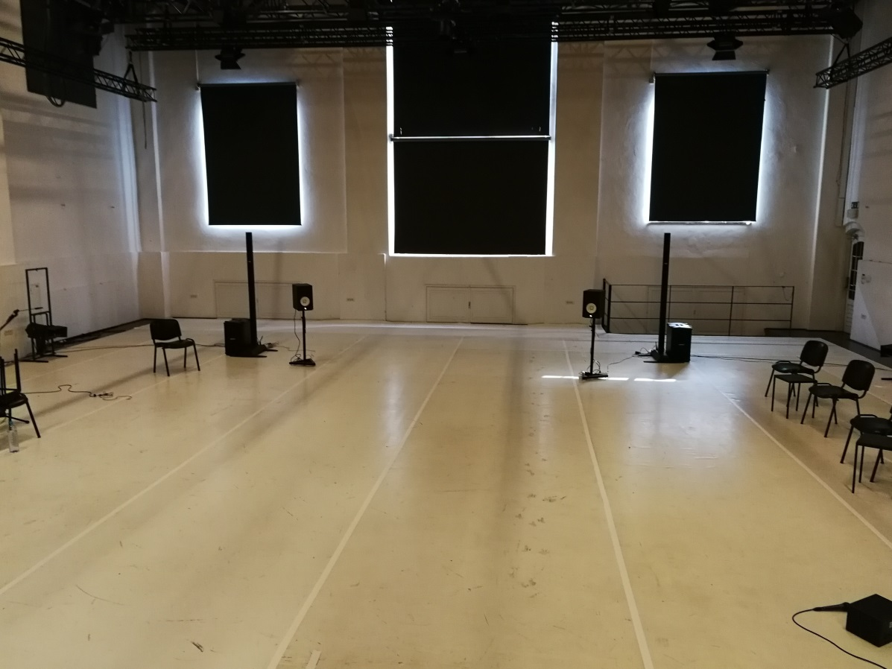

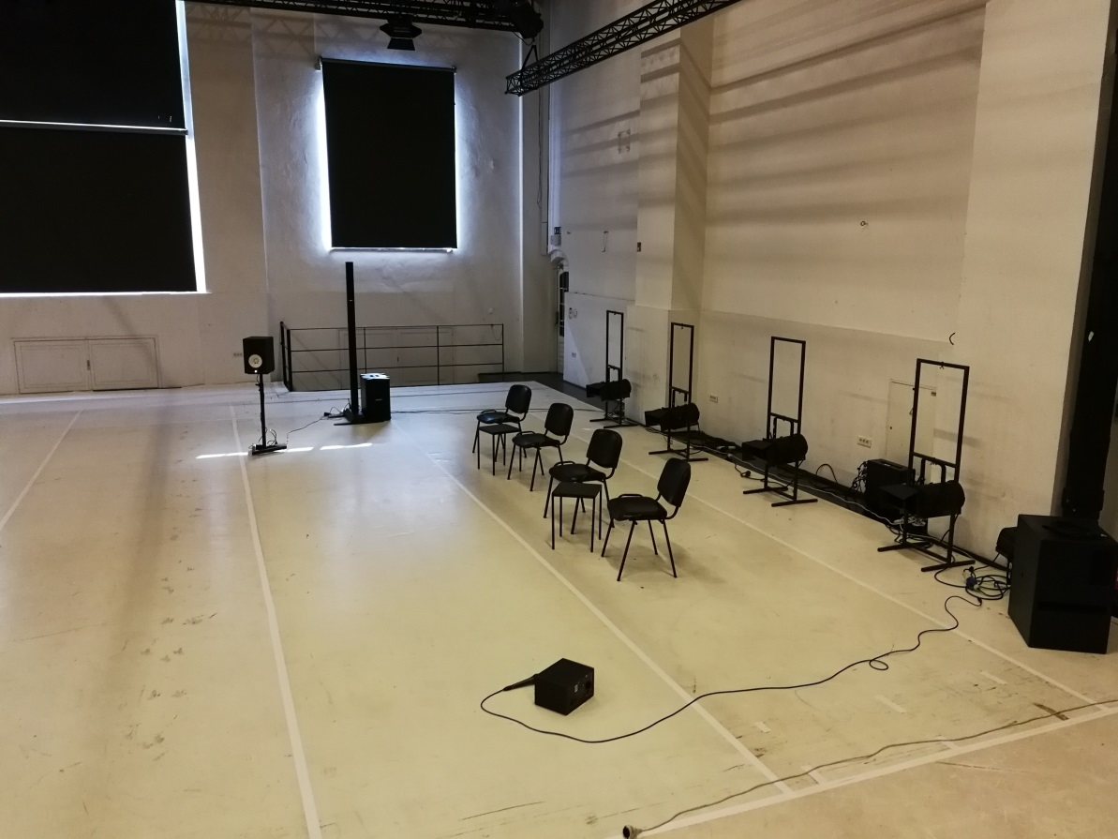

Performance coordinator: Sabina Potočki, 031.608.456, sabina@emanat.si
Technical crew:
Urška Vohar, oblikovanje luči, kontakt: 040.276.618, urska.vohar@gmail.com
Tomaž Grom, oblikovanje zvoka, kontakt: 041.912.849, gromtomaz@gmail.com

